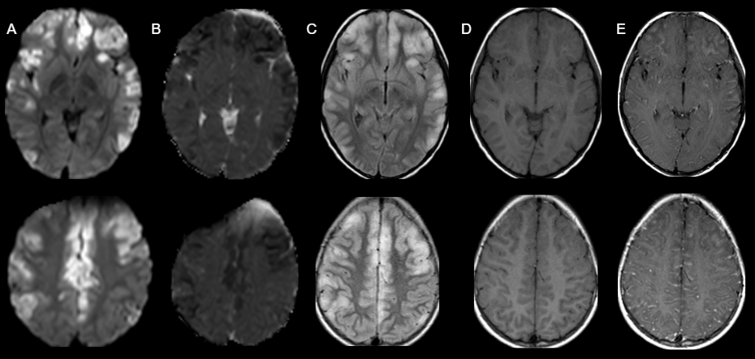
Figure 1. A: DWI. (Diffusion weighted images) Restricted cortical areas in both hemispheres (bifrontal, temporo-insular and parietal) B: ADC (apparent diffusion coefficient) Hypo intensity on ADC map of restrictive focal areas. C: FLAIR. Hyperintense focal lesions with cortical involvement exclusively. Mild cortical thickening in affected areas. D: T1 without gadolinium. E: T1 with gadolinium. Contrast images showing leptomeningeal enhancement, predominantly of the left frontal cortex.

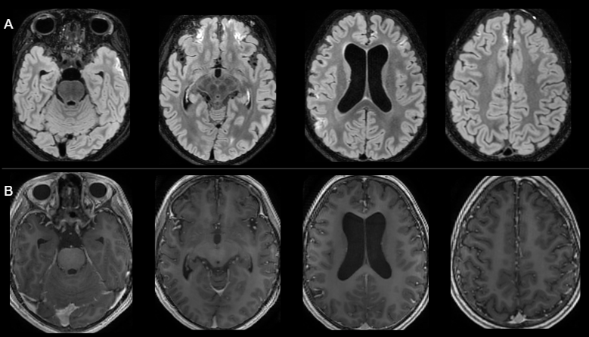
Figure 2. Control MRI. A: Vanishing of some of the focal lesions was observed, as well as thinning and retraction of remaining cortical areas showing hyperintense signal in FLAIR in left temporal, frontal and right parietal lobes, possibly linked to gliosis or cortical laminar necrosis. B: Disappearance of leptomeningeal enhancement. Of note: ventricular volume increase was observed, predominantly of the lateral ventricles, probably related to steroid therapy.

