POSTERIOR REVERSIBLE ENCEPHALOPATHY SYNDROME IN PEDIATRICS

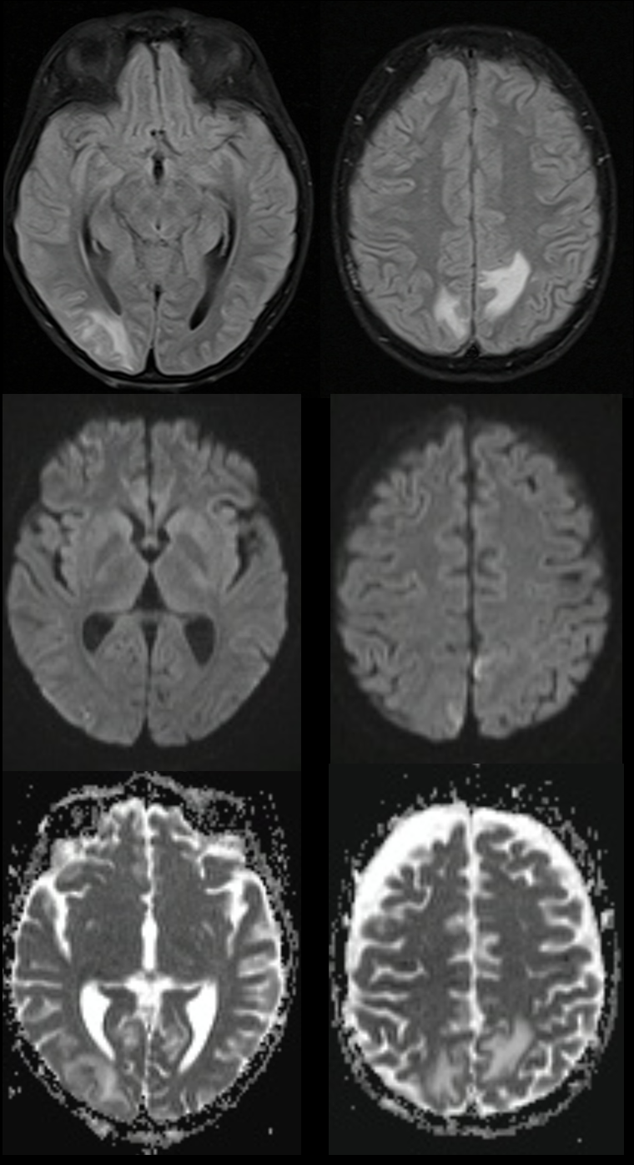
Figure 1- FLAIR-weighted MRI, DWI, ADC. Hyperintense lesions on FLAIR in right occipital subcortical and paramedian posterior parietal topography, without diffusion restriction.
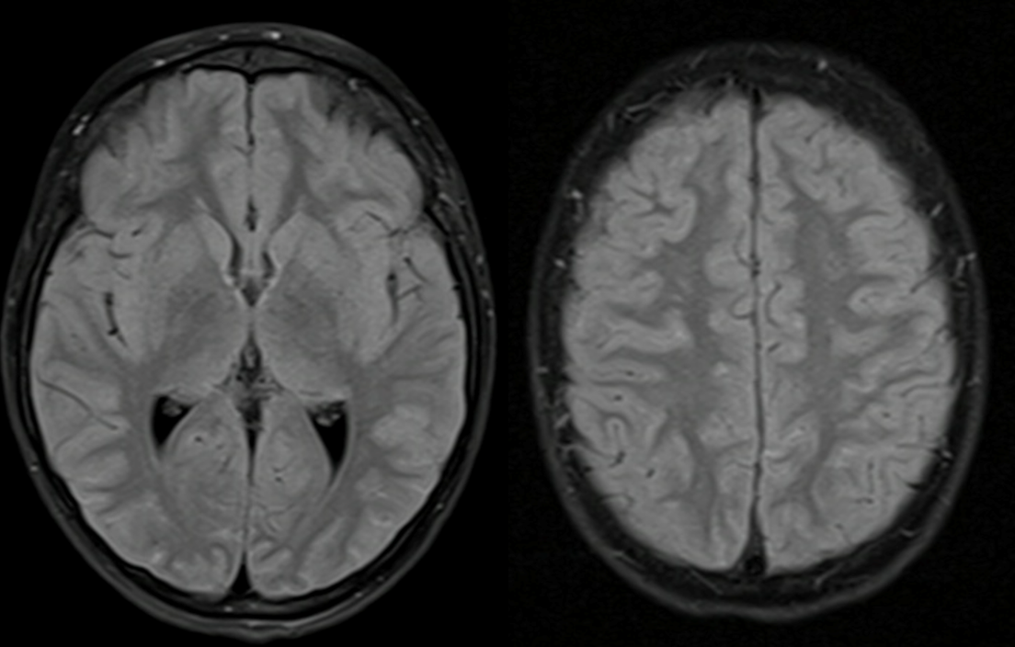
Figure 2- FLAIR-weighted control MRI showing full recovery.

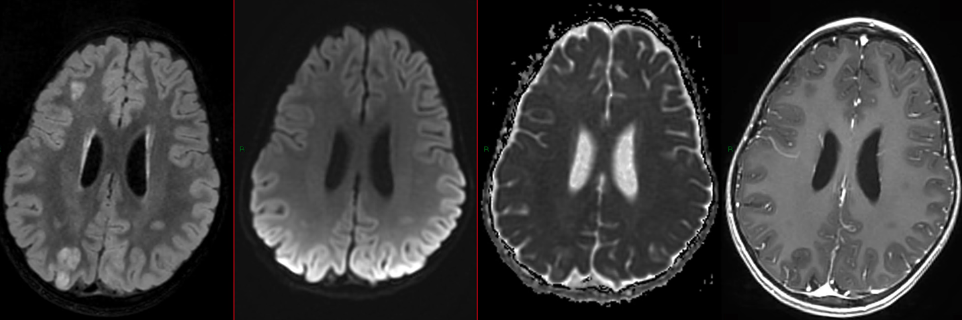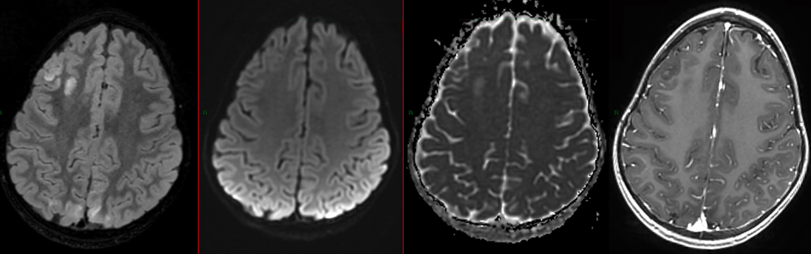

Figure 3- Weighted MRI in FLAIR, DWI, ADC and T1+Gd. Hypertensive lesions on FLAIR in posterior, parieto-occipital and superior frontal subcortical topography, without diffusion restriction or post-gadolinium enhancement.

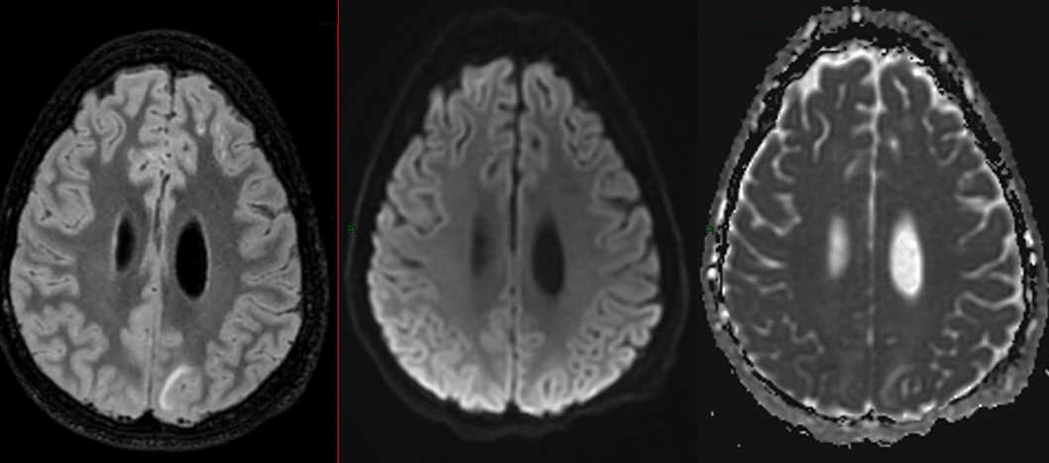
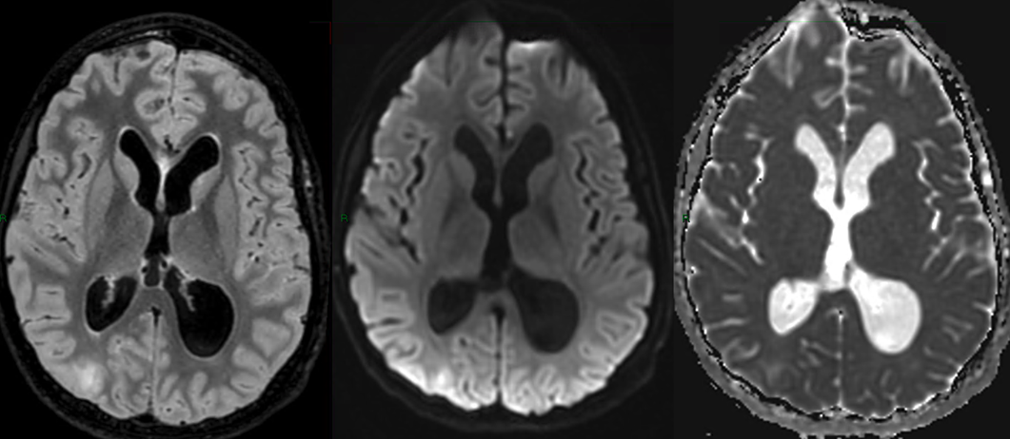
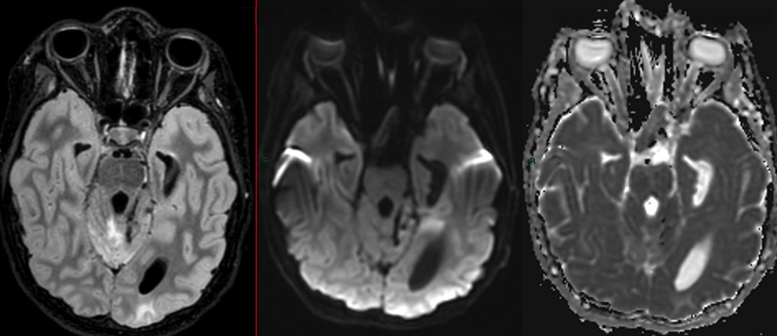

Figure 4- FLAIR-weighted MRI, DWI, ADC. Hypertensive lesions on FLAIR in left occipital subcortical and paramedian posterior parietal topography, without diffusion restriction.

