Table 1. Comparison of clinical data between relapse and non-relapse groups data between
 | Relapse group (n=37) | Non-relapse group (n=27) | Test statistics | p-value
Gender (male/female) | 25/12 | 15/12 | 0.961 | 0.434ª
Presence of hypsarrhythmia before ACTH treatment | 28 | 24 | 1.789 | 0.213ª
Pathogenic structural abnormalities on MRI | 8 | 6 | 0.003 | 1ª
Definitive etiology | 20 | 10 | 1.815 | 0.211ª
Number of ASMs |  |  |  | 0.594^{b}
1 | 18 | 16
2 | 13 | 9
3 | 6 | 2
VPA exposure history | 20 | 8 | 3.784 | 0.075ª
TPM exposure history | 33 | 24 |  | 1.000^{b}
VGB exposure history | 1 | 2 |  | 0.568^{b}
Hormonal therapy history | 5 | 3 |  | 1.000^{b}
Presence of hypsarrhythmia after ACTH treatment (month) | 6 | 1 |  | 0.223^{b}
Interval from onset to initiation of ACTH treatment (month) | 2 (1,5) | 1.5 (0.75,3) | 1.576 | 0.116^{c}
Age at spasms onset (month) | 6 (4,7.5) | 6 (4,7) | 0.475 | 0.640^{c}
Frequency of spasms (count per day) | 25 (13,75) | 45 (15,95) | 1.176 | 0.243^{c}
Dosage of ACTH (IU/kg) | 2.70.43 | 2.770.43 | 0.61 | 0.544^{d}
BASED score |  |  |  | 0.001^{b}
0 | 2 | 9
1 | 6 | 8
2 | 4 | 7
3 | 7 | 1
4 | 9 | 1
5 | 9 | 1
Note: a bold p-value indicates statistically significant; data are expressed as number, mean standard deviation, or median (range).
Abbreviations: ACTH, Adrenocorticotropic Hormone; ASM, anti-seizure medication; BASED, Burden of Amplitudes and Epileptiform Discharges; TPM, toiramate; VGB, vigabatrin; VPA, valproate.
ª Chi-square test.
^{b} Fisher's exact test (test statistic is identical with p-value).
^{c} Rank-sum test.
^{d} Independent two-sample t-test.

Table2. Cox regression analysis of relapse risk factors in children with 64 infantile spasms who achieved a short-term response.
Model 1: Univariate cox regression analysis.
 | HR | 95% Confidence interval for hazard ratio |  | P
 | HR | Lower | Upper | P
Gender(Male/Female) | 0.73 | 0.37 | 1.46 | 0.4
Presence of hypsarrhythmia before ACTH treatment | 0.58 | 0.27 | 1.23 | 0.2
Pathogenic structural abnormalities on MRI | 0.93 | 0.42 | 2.03 | 0.9
Definitive etiology | 1.57 | 0.82 | 3 | 0.2
Number of ASMs | 1.44 | 0.91 | 2.28 | 0.12
VPA exposure history | 1.97 | 1.03 | 3.77 | 0.041
TPM exposure history | 0.89 | 0.31 | 2.51 | 0.8
VGB exposure history | 0.5 | 0.07 | 3.68 | 0.5
Hormonal therapy history | 1.03 | 0.4 | 2.64 | 0.91
Presence of hypsarrhythmia after ACTH treatment | 3.18 | 1.31 | 7.71 | 0.011
Interval from onset to initiation of ACTH treatment | 1.09 | 1 | 1.19 | 0.45
Age at spasms onset | 1.04 | 0.94 | 1.15 | 0.5
Frequency of spasms | 1 | 0.99 | 1 | 0.3
Dosage of ACTH(IU/kg) | 0.87 | 0.39 | 1.95 | 0.7
BASED score | 1.56 | 1.28 | 1.89 | ＜0.001
Model 2： Multivariate COX regression analysis
Definitive etiology | 1.24 | 0.59 | 2.63 | 0.6
Presence of hypsarrhythmia after ACTH treatment | 2.31 | 0.8 | 6.7 | 0.12
VPA exposure history | 1.65 | 0.77 | 3.62 | 0.2
Interval from onset to initiation of ACTH treatment | 0.96 | 0.86 | 1.08 | 0.5
Presence of hypsarrhythmia before ACTH treatment | 0.67 | 0.26 | 1.69 | 0.4
Number of ASMs | 1.45 | 0.84 | 2.51 | 0.2
BASED score | 1.48 | 1.18 | 1.87 | ＜0.001
Note: Bold P value is statistically significant
Abbreviations: ACTH, Adrenocorticotropic Hormone; ASM, anti-seizure medication; BASED, Burden of Amplitudes and Epileptiform Discharges; TPM, topiramate; VGB, vigabatrin; VPA, valproate.

Figure 1. Multivariate Cox regression analysis of relapse risk factors in children with infantile spasms (64 cases) who achieve a short-term response.

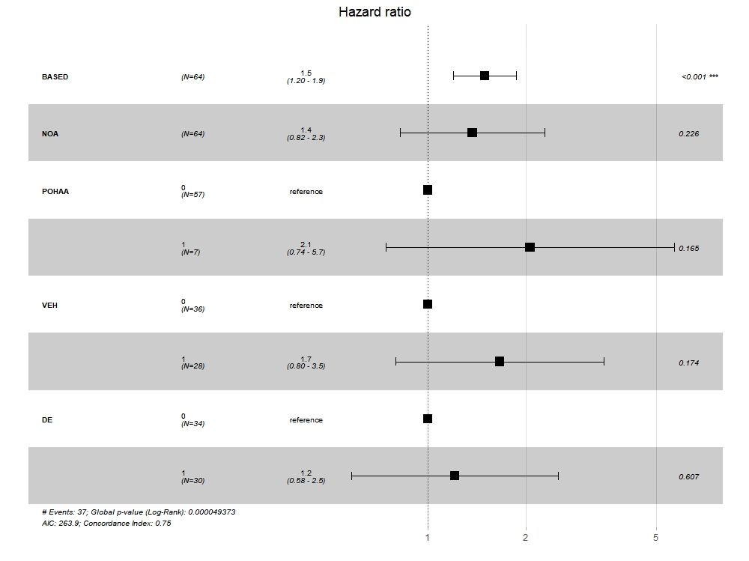
Abbreviations: DE, Definitive etiology； NOA, Number of anti-seizure medication； POHAA, Presence of hypsarrhythmia after ACTH； VEH, VPA exposure history=VEH

Figure 2. Kaplan–Meier (KM) survival curves for the patients with a short-term response after ACTH treatment.
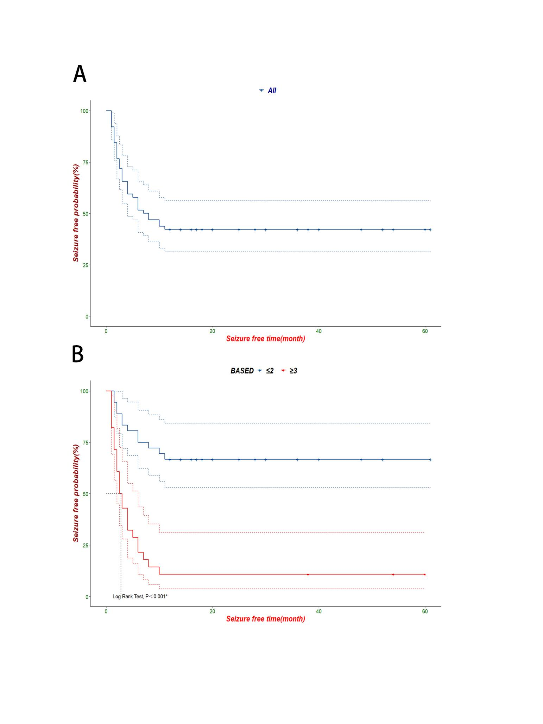

A. Survival curves for the patients with a short-term response after ACTH treatment.
B. Survival curves with a cutoff value of BASED score (≥3 or ≤2) for the patents with a short-term response after ACTH treatment.

Figure 3. Pipeline of the EEG-based functional connectivity states analysis

Figure 4. Functional connectivity measure of 24 patients.
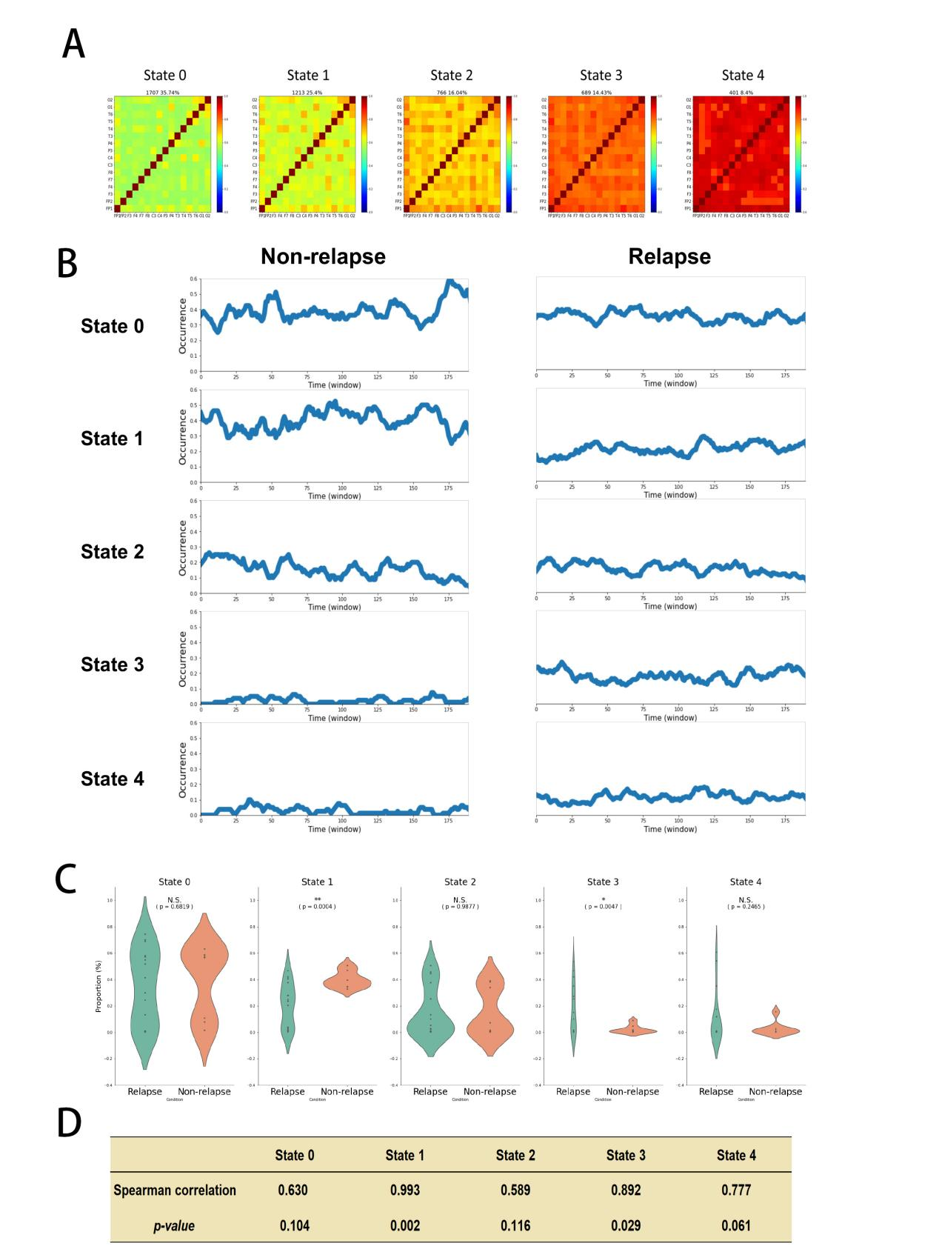
- .Functional connectivity states, red, stronger, green, weaker；
- Occurrences of each state during the BASED scoring epoch in the non-relapse and relapse group separately.
- State 0-4 comparations between non-relapse and relapse group；
- Correlations between states and BASED score.

