Table 1. Demographic and clinical characteristics of children (N=604) with childhood epilepsy, centrotemporal spikes (CECTS).

 | Monotherapy | Dual therapy | P
n | 450 (74.5%) | 154 (%25.5)
Age (years) | 9.3±2.3 | 8.8±5.3 | 0.003
Gender  Female / Male | 189/261 | 55/99
Age at onset of seizures (months) | 10.5±4.2 | 7.1±3.3 | 0.004
History of febrile fever | 36 (8%) | 15 (9.7%) | 0.250
Family history | 75 (16.6%) | 28 (18.1%) | 0.320
EEG improvement (SWI)%  ≥50%  <50% | 27.2  72.8 | 30.7  69.3 | 0.008  0.060
Unilateral discharges (%)  Bilateral dscharges (%) | 50.4  39.6 | 45.5  55.5 | 0.150  0.006
Age at onset of seizures (years)  <5  5-10  >10 | 91 (20.2%)  334 (74.2%)  54 (12.0%) | 39 (25.3%)  81 (52.5%)  5 (3.2%) | 0.007  0.060  0.014
Time of seizure  Sleep/Wakeful | 290 (64.4%)/160 (36.6%) | 98 (63.6%)/56 (36.3) | 0.051
EEG  Unilateral  Bilateral | 203 (35.9%)  401 (61.1%) | 40 (25.7%)  114 (71.3%) | 0.023  0.005

SWI: Spike-wave index

Table 2. The comparison of monotherapy groups with respect to ASM response and EEG
 | VPA  (n=97) | CBZ  (n=240) | LEV  (n=113) | P
Seizure Response
Seizure frequency
2-5 per year | 78 | 219 | 110
6-12 per year | 13 | 11 | 1
1-5 per month | 6 | 10 | 2
Time from the first seizure to the initiaiton of monotherapy (months) | 12.5±4.4 | 15.0±3.4 | 11.6±4.8 | p^{1:}0.038, p²: 0.053, p³:0.010
Seizure-free period since the initiation of monotherapy (months) | 36.9±28.0 | 29.8±21.0 | 22.4±15.2 | p^{1:}0.208, p²:0.023, p³:0.013
Complete seizure control | 71 (%73.1) | 190 (%79.1) | 98 (%86.7) | LEV vs. CBZ; 0.03, LEV vs. VPA; 0.06  LEV vs. CBZ; 0.99, LEV vs. VPA; 0.89  LEV vs. CBZ; 0.05, LEV vs. VPA; 0.02
50% reduction in seizures | 15 (15.4%) | 18 (7.5%) | 15 (13.2%)
Total response | 86 (88.6%) | 208 (86.6%) | 108(95.5%)
EEG Improvement
Time from the initiaiton of monotherapy to EEG remission time (months) | 23.9±11.9 | 18.9±17.6 | 17.4±15.3 | p¹0.025, p²:0.126, p³:0.212
Time to the initiation of dual therapy (months) | 6.4±1.5 | 9.6±0.6 | 8.8±0.5 | p¹0.520, p²:0.602, p³:0.605
EEG remission time (months) | 74.8±55.5 | 64.4±51.89 | 63.2±55.5 | p¹0.480, p²:0.687, p³:0.671
Complete recovery | 19 (19.5%) | 25 (10.4%) | 18 (15.9%) | LEV vs. CBZ <0.001, LEV vs. VPA; 0.07  LEV vs. CBZ<0.001, LEV vs. VPA; 0.66  LEV vs. CBZ <0.001, LEV vs. VPA; 0.05
Response | 40 (41.2%) | 118 (49.1%) | 45 (39.8%)
Complete response | 59 (60.8%) | 143 (34.2%) | 63 (55.7%)
Increase in seizure frequency | 0 (0.0%) | 12 (5.0%) | 0 (0.0%)
Baseline SWI  ≥50%  <50% | 31 (31.9%)  66 (68.0%) | 68 (28.3%)  172 (71.6%) | 19 (16.8%)  94 (83.1%) | LEV vs. CBZ; 0.012, LEV vs. VPA; 0.024  LEV vs. CBZ <0.001, LEV vs. VPA; 0.018
First-year SWI  ≥50%  <50% | 28 (28.8%)  69 (71.1%) | 68 (28.3%)  172 (71.6%) | 22 (19.4%)  91 (80.5%) | LEV vs. CBZ <0.001, LEV vs. VPA; 0.002  LEV vs. CBZ <0.001, LEV vs. VPA; 0.025
Second-year SWI  ≥50%  <50% | 17 (17.5%)  74 (76.2%) | 41 (17.0%)  199 (82.9%) | 8 (7.1%)  105(92.9%) | LEV vs. CBZ <0.001, LEV vs. VPA; 0.033  LEV vs. CBZ <0.001, LEV vs. VPA; 0.027
VPA: Valproic acid, CBZ: Carbamazepine, LEV: Levetiracetam

Table 3. Spike wave index (SWI) evolution in serial EEG; monotherapy versus dualtherapy

 | Monotherapy (n=450) |  |  |  | Dual therapy (n=154)
Age groups (n) | Baseline SWI | First-year SWI | Second-year SWI | p | Baseline SWI | First-year SWI | Second-year SWI | p
<5 years (n=130) | 31.3±13.8 | 31.8±15.8 | 26.0±16.5 | 0.000 | 34.16±10.5 | 41.7±33.0 | 35.5±15.0 | 0.005
5-10 years (n=415) | 29.0± 17.3 | 27.5± 16.5 | 20.0± 15.8 | 0.000 | 37.6±18.6 | 38.1±34.6 | 34.2±12.2 | 0.002
>10 years (n=59) | 28.4±14.4 | 26.4±10.0 | 26.6±14.6 | 0.000 | 20.9±19.4 | 30.2±20.4 | 35.0±16.3 | NS
p | 0.042 | 0.024 | 0.032 |  | 0.012 | 0.019 | 0.550

SWI: Spike-wave index
NS: non-significant. (•) p<0.05

Figure 1. SWI rates in subsequent EEG recording according to the age at the onset of seizures

Figure 2. SWI evolution in serial EEG recording of children receiving monotherapy and dual theraphy

AUC: 0.613 [Cl: 0.526-0.700], Cutoff value: 8.5, Sensitivity: 56.4, Specificity: 65.5, PPD: 29.0, NPD: 85.7
Figure 3. The predictive value of SWI for ASM selection with comparison of LEV and VPA.
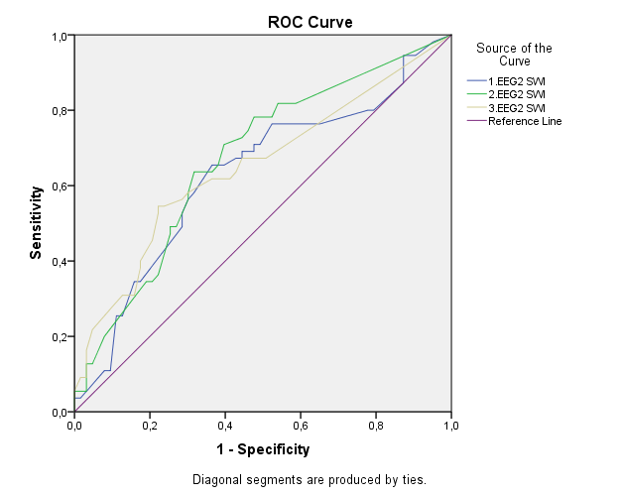
For baseline EEG; AUC: 0.630 [Cl: 0.527-0.733], Cutoff value: 14.5, Sensitivity: 61.8 Specificity: 63.1 PPD: 58.6 NPD: 66.1, p=0.015; for first-year EEG; AUC: 0.671 [Cl: 0.574-0.769], Cutoff value: 11.5, Sensitivity: 58.7, Specificity: 62.6, PPD: 52.4, NPD: 68.4, p=0.001; for second-year EEG; AUC: 0.649 [Cl: 0.549-0.750], Cutoff value: 5.5, Sensitivity: 58.6, Specificity: 67.0, PPD: 57.7, NPD: 67.8, p=0.005

Figure 4. The predictive value of SWI for ASM selection with comparison of LEV and CBZ..

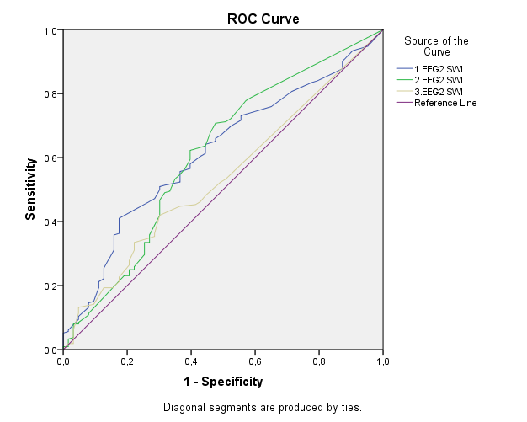

For baseline EEG; AUC: 0.616 [Cl: 0.540-0.692], Cutoff value: 23.5, Sensitivity: 55.3, Specificity: 67.3, PPD: 80.6, NPD: 38.1, p=0.005; for first-year EEG; AUC: 0.611 [Cl: 0.528-0.694], Cutoff value: 5.5, Sensitivity: 67.5, Specificity: 59.3, PPD: 81.6, NPD: 40.6, p=0.008

Figure 5. The predictive value of SWI for ADHD in children with CECTS.
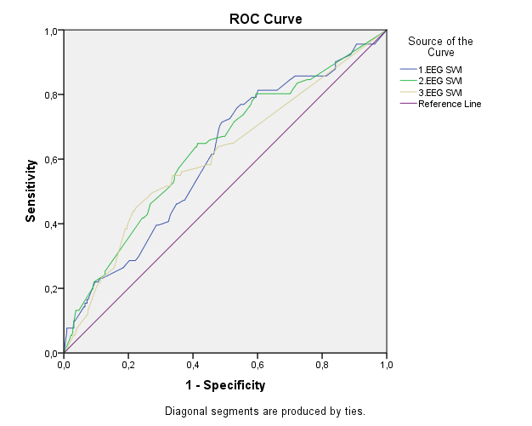

For first-year EEG: AUC: 0.607 [Cl: 0.552-0.672], Cutoff value: 33.5, Sensitivity: 59.8, Specificity: 59.2, PPD: 26.7, NPD: 85.6; for second-year EEG: AUC: 0.630 [Cl: 0.564-0.696], Cutoff value: 10.0, Sensitivity: 61.5, Specificity: 54.1, PPD: 26.9, NPD: 83.6; for third-year EEG: AUC: 0.607 [Cl: 0.538-0.675], Cutoff value: 3.5, Sensitivity: 69.2, Specificity: 40.2, PPD: 22.4, NPD: 83.9

