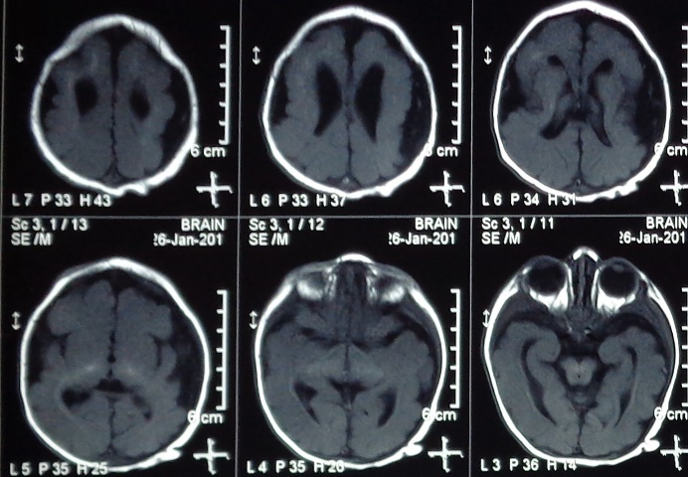

Figure : MRI Brain T1W images showing pachygyria, lissencephaly and agenesis of corpus callosum with calcification involving periventricular areas, bilateral thalami and midbrain

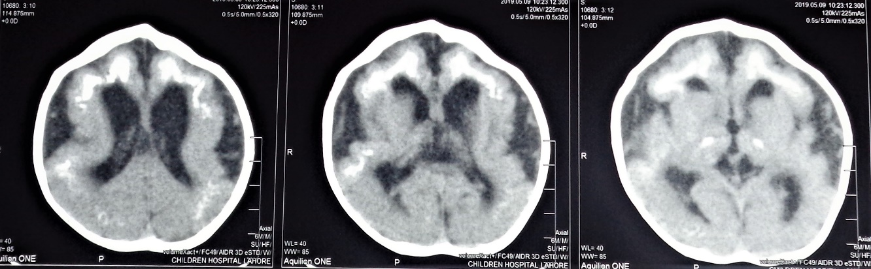

Figure :CT Brain showed extensive parenchymal, thalamic calcification with atrophic changes