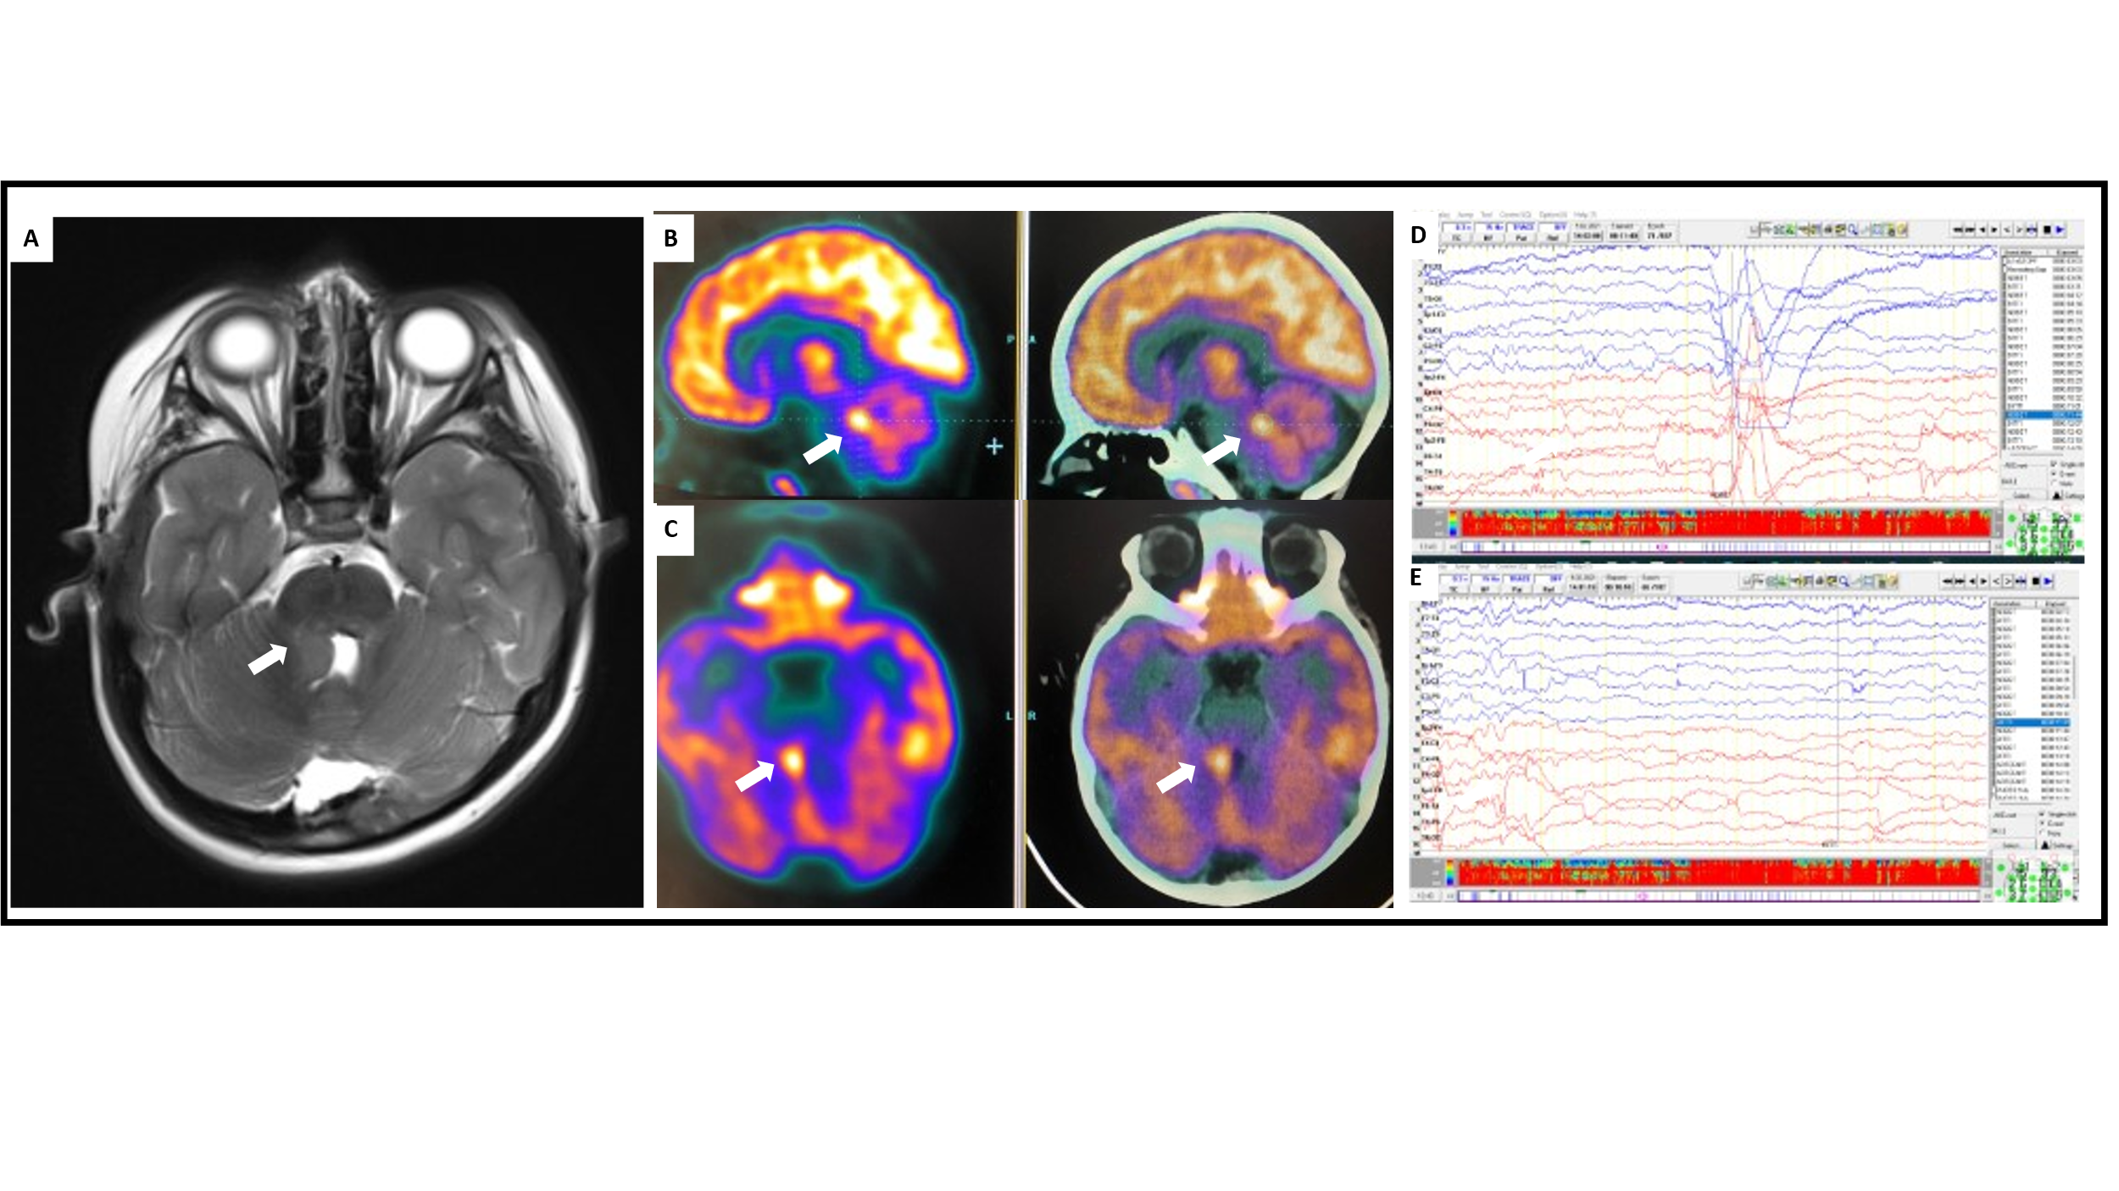

**Figure1. (A)** Axial T2-weighted MRI showed the cerebellar hamartoma in the right cerebellar pedincule, **(B)** sagital, and **(C)** axial PET/CT images revealed ictal hypermetabolic area in the right cerebellar pedincule. **(D)** normal interictal EEG recording, **(E)** generalized voltage attenuation predominant at the right side during the ictal video-EEG recording.