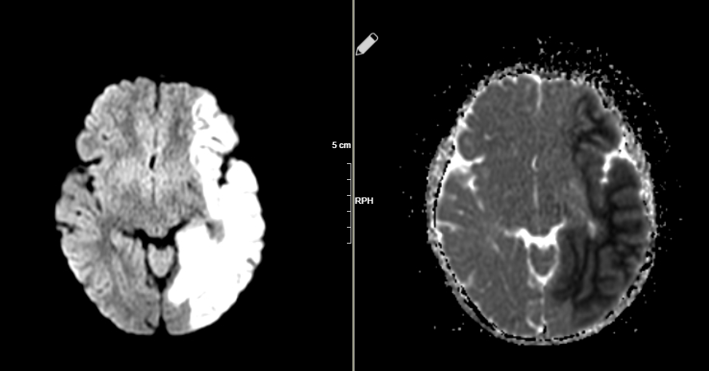

Figure1: Diffusion and ADC images

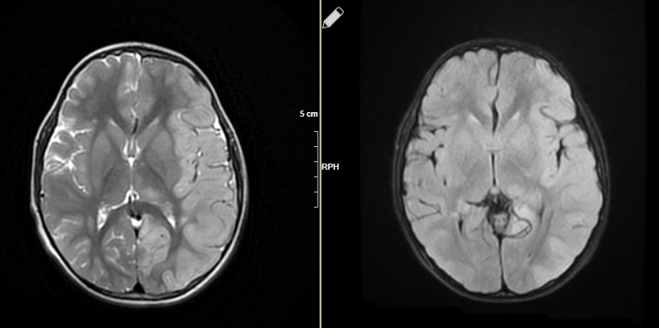

Figure2: Axial T2 ve FLAIR images