**Figure 1: Frequency Breakdown of Atypical Clinical Features**

**Table I: Neuroimaging and Electroencephalography Characteristics of Patients**

| **Characteristic** | **Value** |
| --- | --- |
| **Neuroimaging Findings**, n (%)  Normal  Cerebral edema  Cortical atrophy  Non enhancing hyper intense signals  Periventricular hyperintesities  Gyriform parieto-temporal hyperintensities  Occipital hyperintensities  Focal cortical hyperintensities  White matter & brainstem signals | 22 (46.8%)  1 (2.1%)  2 (4.3%)  22 (46.8%)  10 (21.3%)  7 (14.9%)  2 (4.3%)  2 (4.3%)  1 (2.1%) |
| **EEG Findings,** n (%)  **Stage A:**  High voltage delta waves with fronto-central accentuation  **Stage B:**  Generalized Burst suppression pattern  Periodic  Aperiodic  **Stage C:**  Generalized slow waves  **Atypical EEG findings:**  Status epilepticus  Focal Burst suppression  Burst of slow waves followed by suppression  GPEDs  Multifocal discharges | 10 (21.3%)  26 (55.3%)  15 (31.9%)  11 (23.4%)  2 (4.3%)  9 (19.1%)  1 (2.1%)  2 (4.3%)  1 (2.1%)  4 (8.5%)  1 (2.1%) |
| SD, standard deviation; GPED, Generalized periodic epileptic discharges. | |

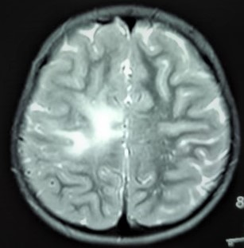 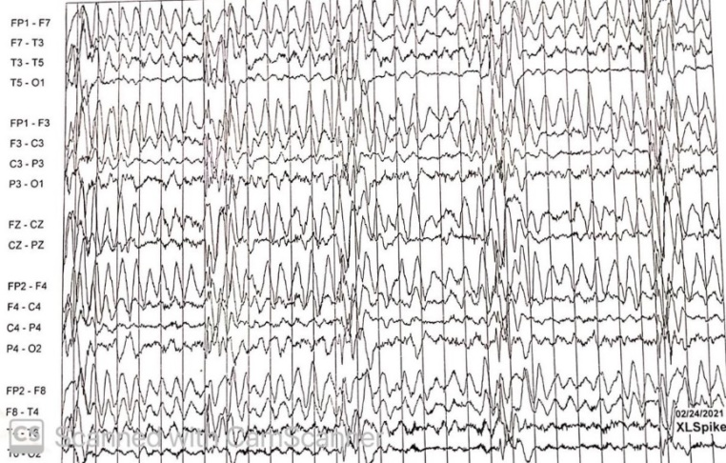

**Figure 2A: T2W Focal Hyperintense Signal Figure 2B: Burst Suppression Pattern**