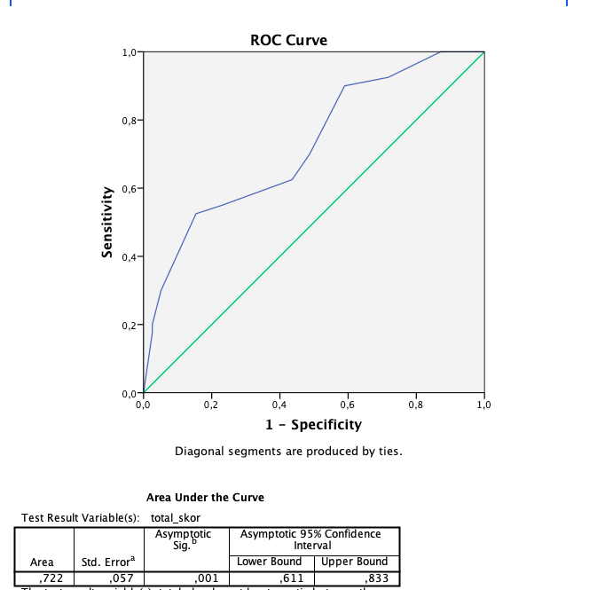

Figure 1: The ROC curve of ENEOSS (The area under curve:72.2)