KEEP AN AYE ON LUMPY BUMPY HEAD: A CASE SERIES HIGHLIGHTING SPECTRUM OF PRESENTATION IN CRANIOSYNOSTOSISCRANIOSYNOSTOSIS

**CASE 1:**

A 2-year-old male came with the complaint of uncontrolled fits for 3 days and fever for 2 days. He was developmentally normal. A clinical diagnosis of meningoencephalitis was made. CT scan showed diffuse meningeal enhancement suggestive of meningitis. Incidentally, there is a fusion of both coronal sutures noted representing brachiocephalic craniosynostosis.

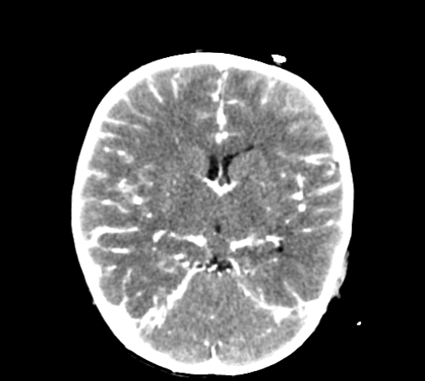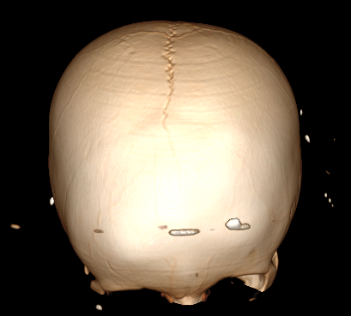

**CASE 2:**

A 6-month-old came with the complaint of developmentally delayed milestones. She had a history of difficult labor. On examination, she has a microcephalic skull. Her CT scan shows dilated ventricles with periventricular and subcortical cystic leukomalacia and periventricular calcification representing hypoxic brain injury. There is a fusion of both coronal sutures noted representing craniosynostosis (Brachycephaly).

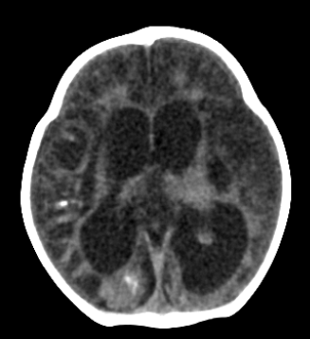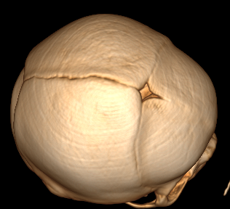

**CASE 3:**

8-month-old came with the complaint of delayed milestones. His CT scan shows a fusion of metopic sutures giving an abnormal shape of the skull. The brain parenchyma appears to be normal. Findings represent craniosynostosis (Trigonocephaly).

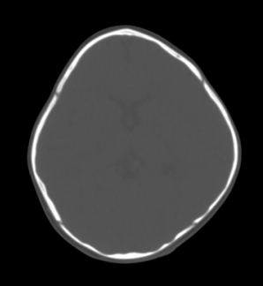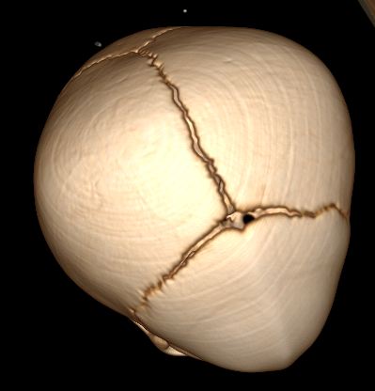

**CASE 4**

A 4-month-old came with a complaint of fits since birth.CT scan shows dilated lateral ventricle with periventricular cystic leukomalacia and prominent subarachnoid space along the bilateral frontotemporal region and interhemispheric fissure representing benign enlargement of subarachnoid space of infancy (BESSI). There is a fusion of both coronal sutures noted representing craniosynostosis (Brachycephaly).

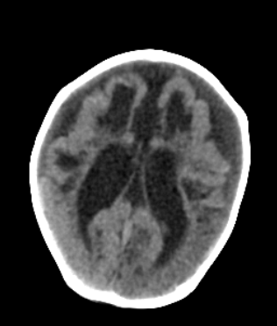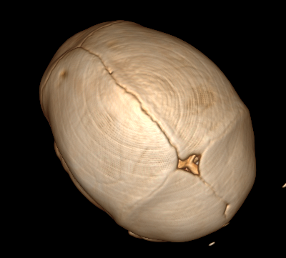

**CASE 5:**

2-month-old came with the complaint of fits on the 6th day of life. On examination, there is over-riding of sutures noted. The CT scan shows fusion and over-ridding of both coronal sutures giving an abnormal shape. Brain parenchyma shows hypodense periventricular areas suggesting hypoxic injury.

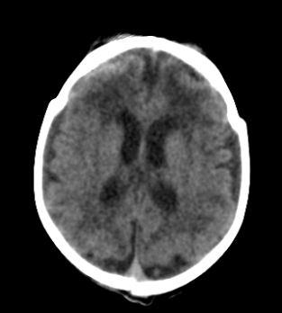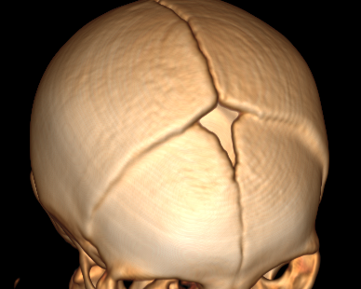

**CASE 6:**

2-year-old came with the complaint of delayed milestones, seizures since birth, and abnormal shape of the head. His CT scan shows an abnormal skull shape with the fusion of metopic sutures representing craniosynostosis (Trigonocephaly)

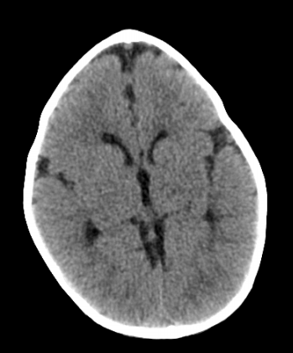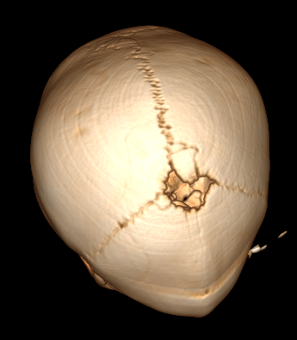

**CASE 7:**

3-Year-old came with the complaint of falling from stairs. The CT scan shows the incidental finding of fusion of sagittal suture giving an abnormal boat shape skull representing craniosynostosis (Dolichocephaly). The brain appears to be normal.

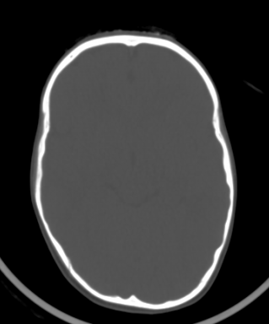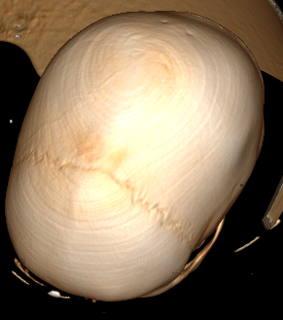

**CASE 8:**

A 5-month-old came with the complaint of delayed milestones. He has a history of delayed crying at birth. His CT scan shows an early fusion of metopic suture, giving an abnormal triangular head representing craniosynostosis (Trigonocephay). Brain parenchyma is normal.

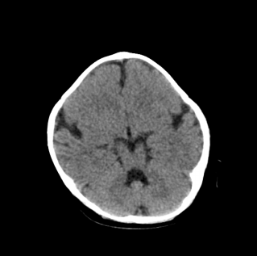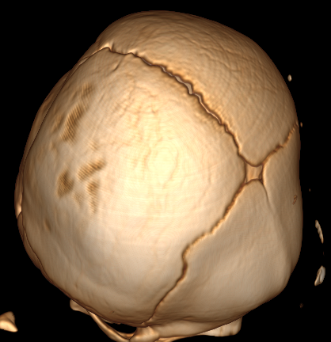

**CASE 9:**

12-year-old came with the complaint of an altered level of consciousness and fit for 6 days. He has a history of delayed milestones. Clinical suspicion of meningoencephalitis was made. A contrast study was not done due to a deranged creatinine level. The CT brain shows hypodense areas in bilateral white matter and basal ganglia and bilateral basal ganglia hyperdensity likely bleed. Incidental finding of fusion of sagittal suture noted (Scaphocephaly).

